**How to Install JDK 11 :**

[**https://drive.google.com/drive/folders/1JpKIJGYTHJq7QZDM2ACGwg-qQ82PruvY?usp=sharing**](https://drive.google.com/drive/folders/1JpKIJGYTHJq7QZDM2ACGwg-qQ82PruvY?usp=sharing)

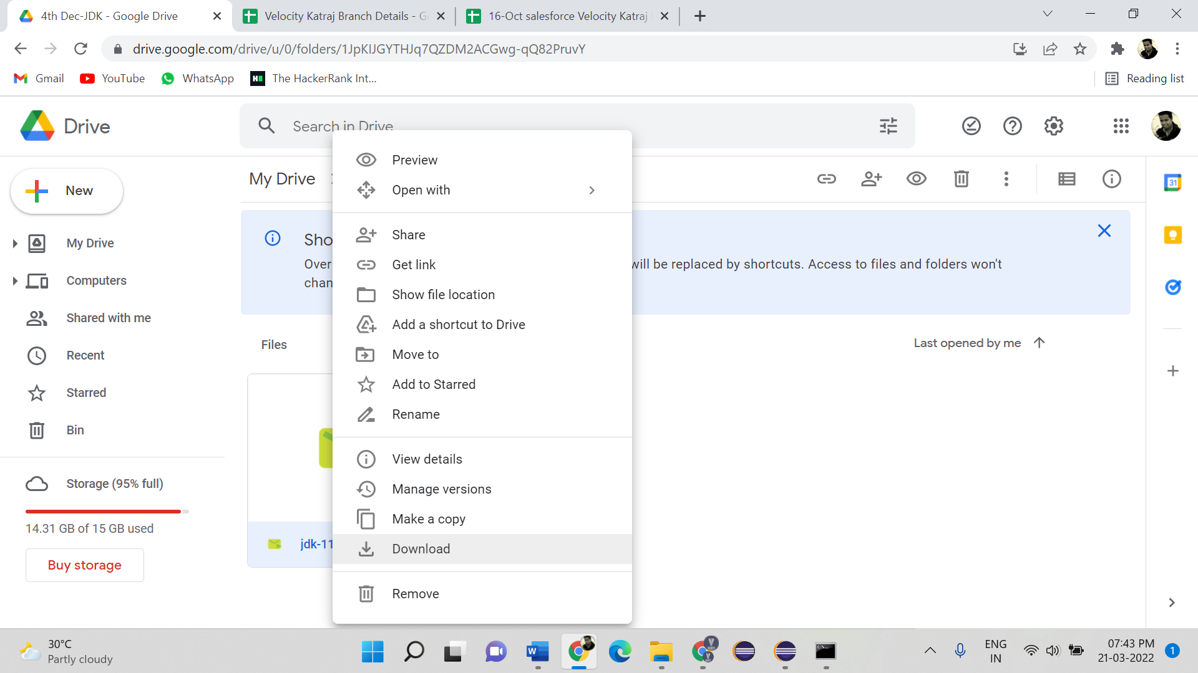

1. **Go to download and search the downloaded file. Then double click on it.** 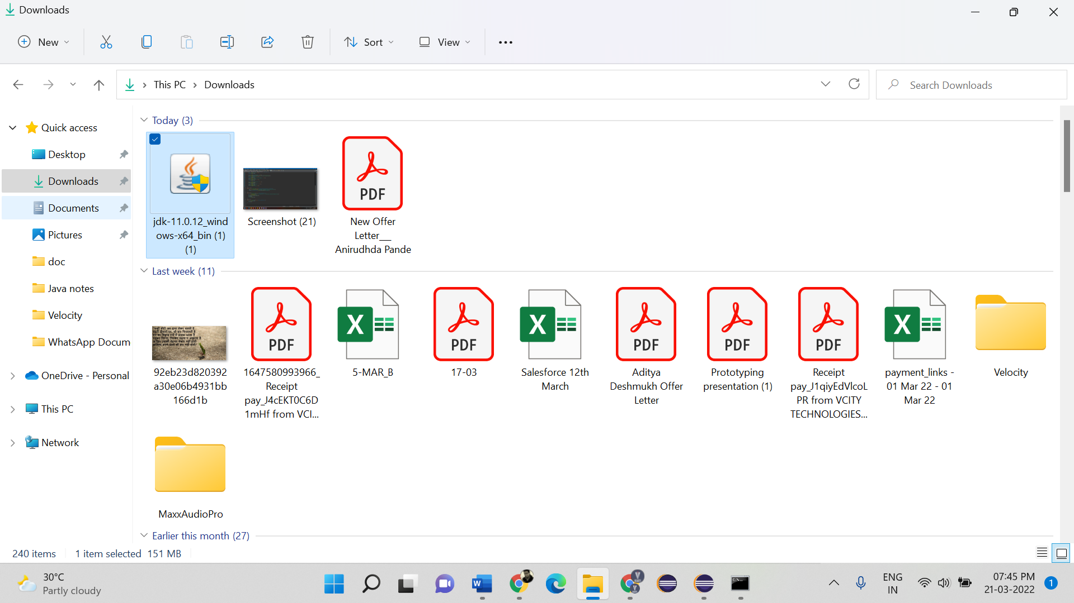
2. **Click on Next** 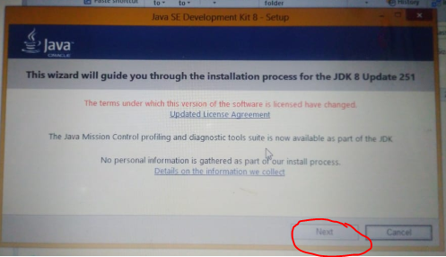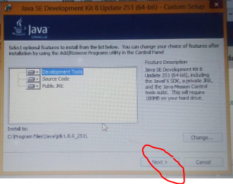
3. **Wait until updating**

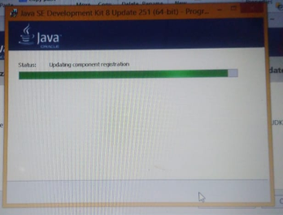

1. **Click on Next**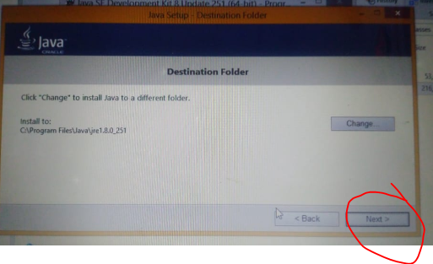
2. **Wait until installing**

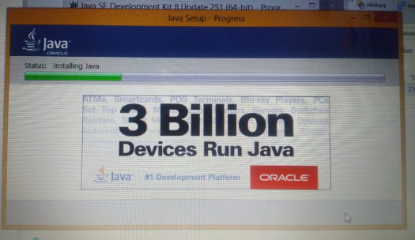

1. **Click on Close**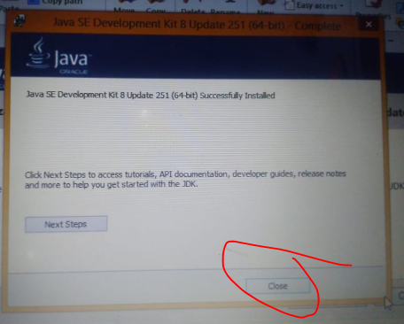
2. **Restart the computer**
3. **Check Java installed Version**

**Search “CMD” in search bar and open “Command Prompt”**

**Enter command “java -version” and hit Enter button**

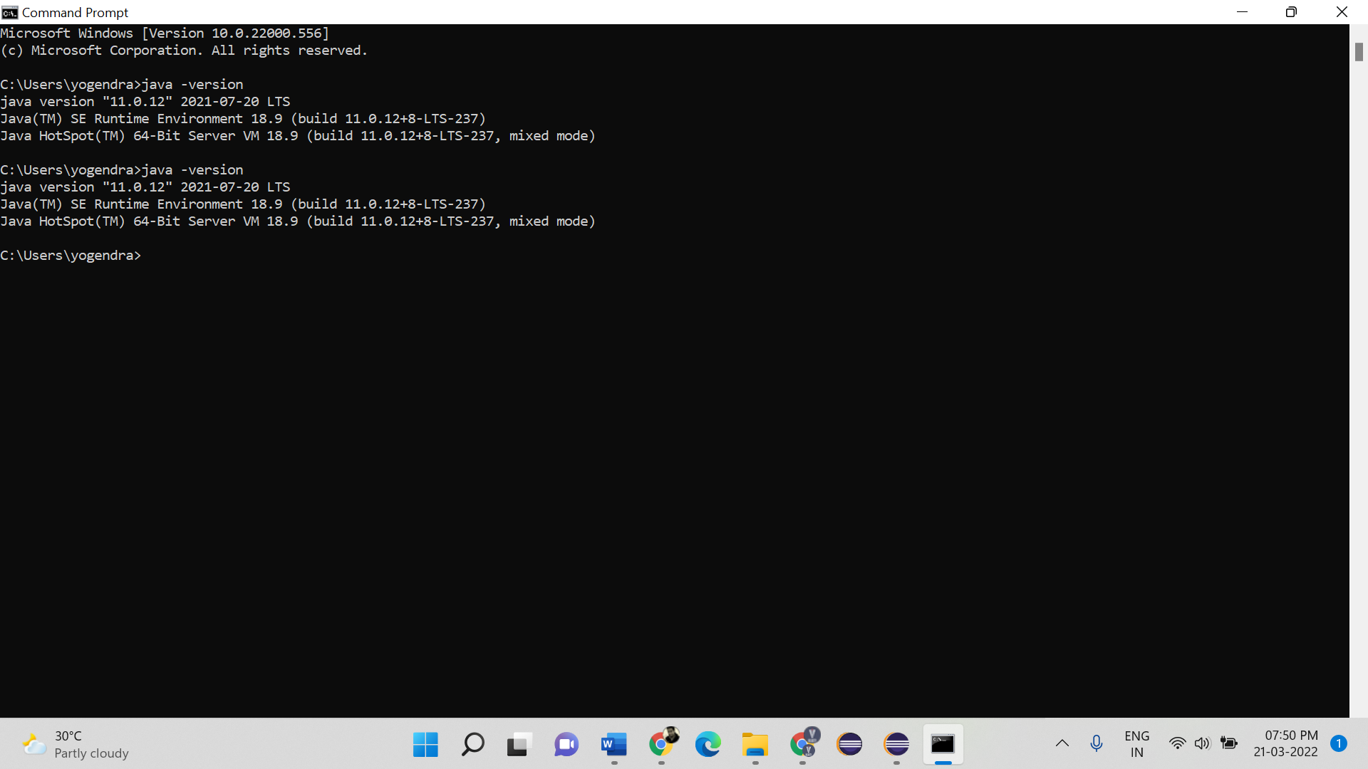

**Setting Environment Variable:**

1. **Open System Properties – Open My Computer and Click on System Properties.**

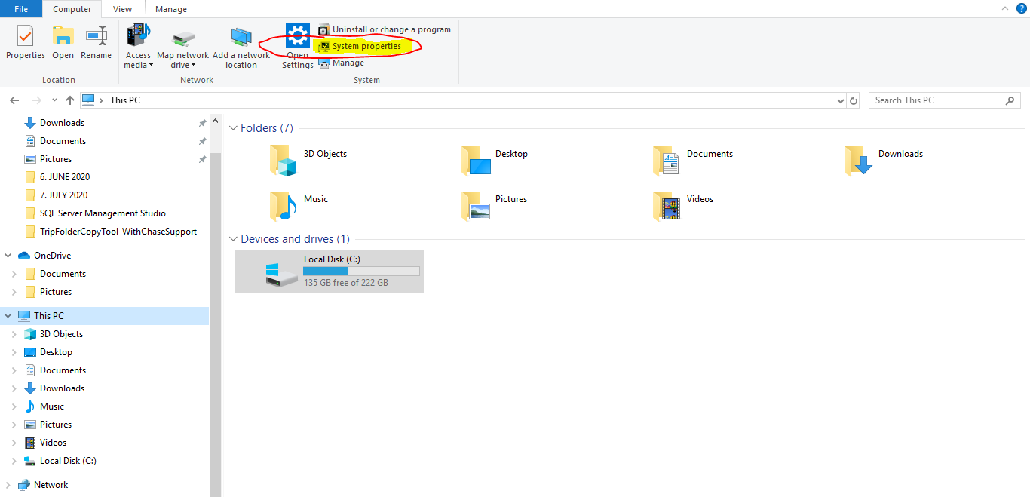

1. **Click on Advance System Setting (Here you can check Operating System and processor 32(x86) or 64(x64)bits )**

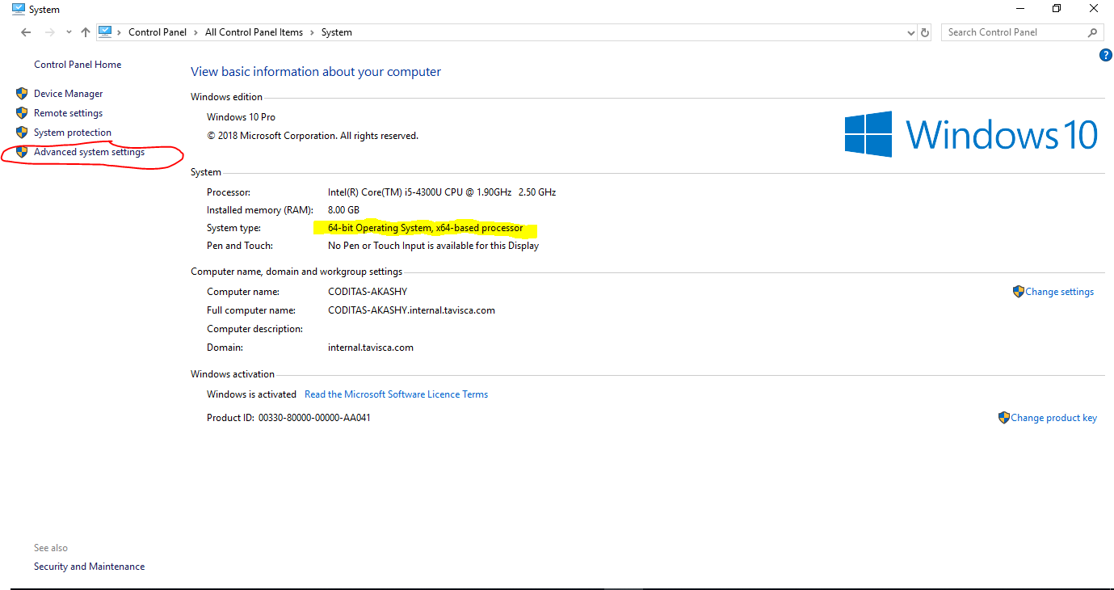

1. **Go to Advance and Click on Environment Variables**

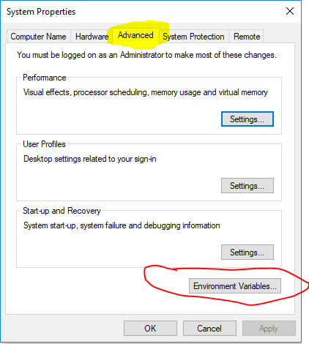

1. **Click on New**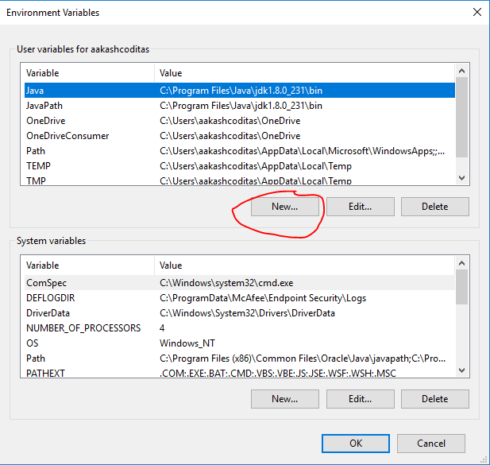
2. **Enter variable Name – (eg.JavaPath/myjava) and Value – C:\Program Files\Java\jdk-11.0.12\bin then click on OK button give path upto bin**

**Path may be common - C:\Program Files\Java\jdk1.8.0_231\bin**

**C:\Program Files (x86)\Java\jdk1.8.0_231\bin**

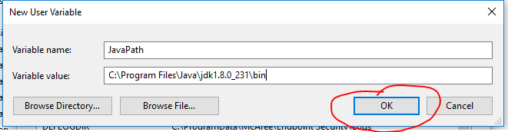

1. **Click on OK button on Environment variables window and then again click on OK button System Properties window**

